Date
ENter Act System Requirements Document
final
The software alchemists
gray masud joel

Table of Contents
Introduction 1
Description Model 1
Class Diagram 1
Use Case Diagram 1
Use Case Scenarios 1
System Sequence Charts 1

Introduction

Welcome to the Systems Requirement Document for Enteract. This document outlines the essential functionalities, interactions, and specifications required for the development and operation of Enteract. With a focus on meeting the diverse needs of members, creators, and sponsors, Enteract aims to revolutionize the social media landscape through its innovative features and user-centric design.

Description Model
1. Output Requirements:
- The system must display streamlined user registration and profile creation forms with clear instructions for users.
- Creator-exclusive content and merchandise must be accessible to users through embedded image links and sponsored content sections.
2. Input Requirements:
- Users must be able to input their personal information, including name, email address, and desired username/password, during the registration process.
- Users should be able to input preferences or interests to personalize content
- The following and unfollowing functionality should allow users to input their choices for creators they wish to follow or unfollow.
3. Process Requirements:
- The system must streamline the user registration and profile creation process to ensure a seamless onboarding experience.
- Challenge-based system processes should facilitate communication and interaction between investors and users, as well as between sponsors and creators.
- Following and unfollowing processes should update user preferences and relationships with creators accordingly.
- Accessing creator-exclusive content and merchandise processes should verify user permissions and display the content securely.
4. Performance Requirements:
- The system should support a large number of concurrent user registrations and profile creations without significant performance degradation.
- Challenge-based system processes should handle a high volume of challenge applications efficiently, ensuring timely responses and notifications.
- Following and unfollowing processes should execute quickly, updating user profiles and connections in real-time.
- Accessing creator-exclusive content and merchandise processes should deliver content promptly, with minimal latency or buffering.
5. Security Requirements:
- User registration and profile creation processes must ensure the security and privacy of personal information, implementing encryption and secure storage practices.
- Challenge-based system processes must authenticate user sponsors and creators, validating their identities and permissions before accepting challenge applications.
- Following and unfollowing processes should authenticate users' actions, preventing unauthorized access to creator accounts or content.
- Accessing creator-exclusive content and merchandise processes should enforce access controls, verifying user permissions and preventing unauthorized sharing or distribution of exclusive content.

Class Diagram
REFER TO GITHUB FOR FILE

Use Case Diagram
REFER TO GITHUB FOR FILE
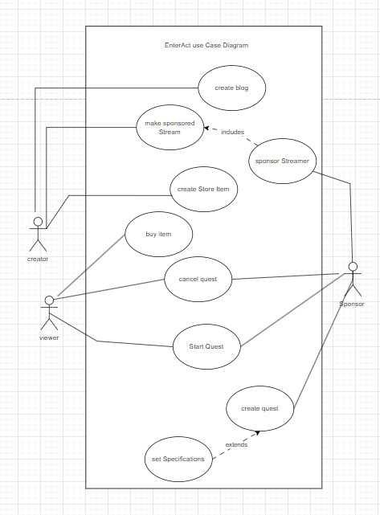

Use Case Scenarios
Refer To github

System Sequence Charts
Refer to github
